Assignment-5.4
NAME:-K.Sunny
HT NO:-2303A52444
BATCH:-43
Task Description #1:
- Prompt GitHub Copilot to generate a Python script that collects user data (e.g., name, age, email). Then, ask Copilot to add comments on how to anonymize or protect this data.
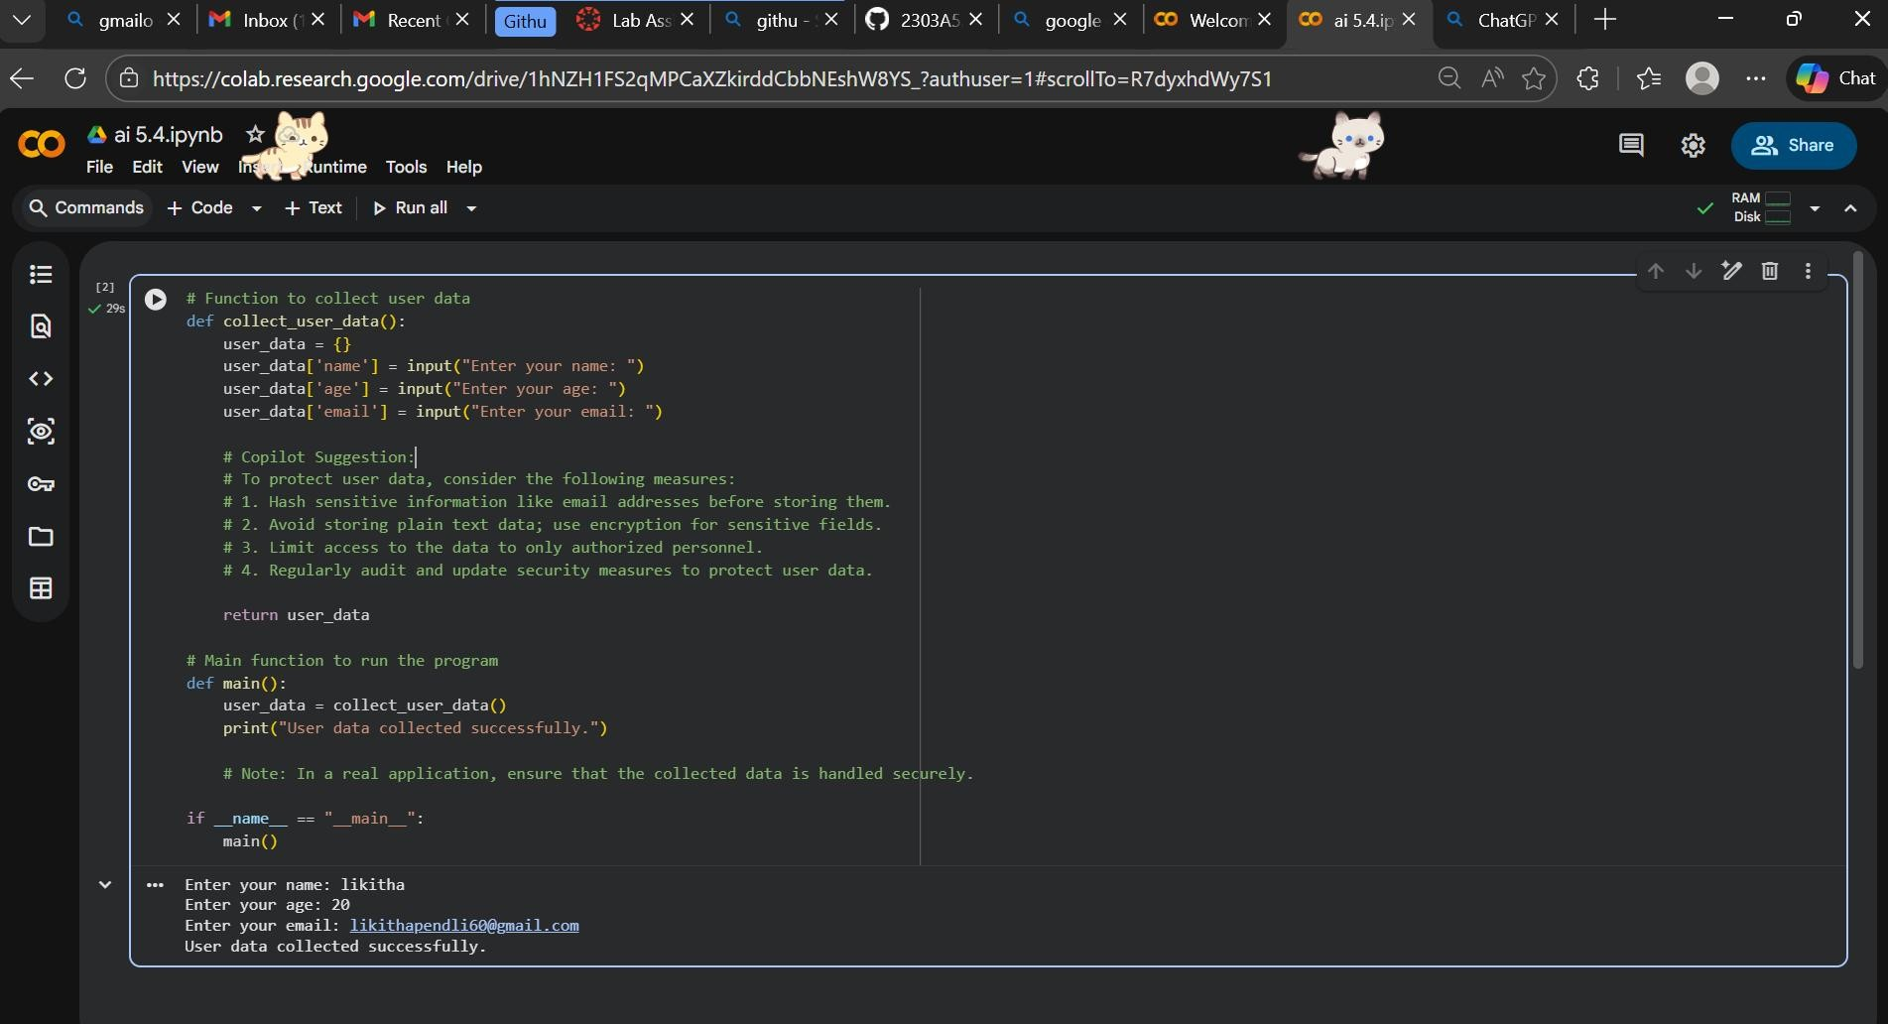
Expected Output #1:
- A script with inline Copilot-suggested code and comments explaining how to safeguard or anonymize user information (e.g., hashing emails, not storing data unencrypted).
Task Description #2:
- Ask Copilot to generate a Python function for sentiment analysis.
Then prompt Copilot to identify and handle potential biases in the
data.
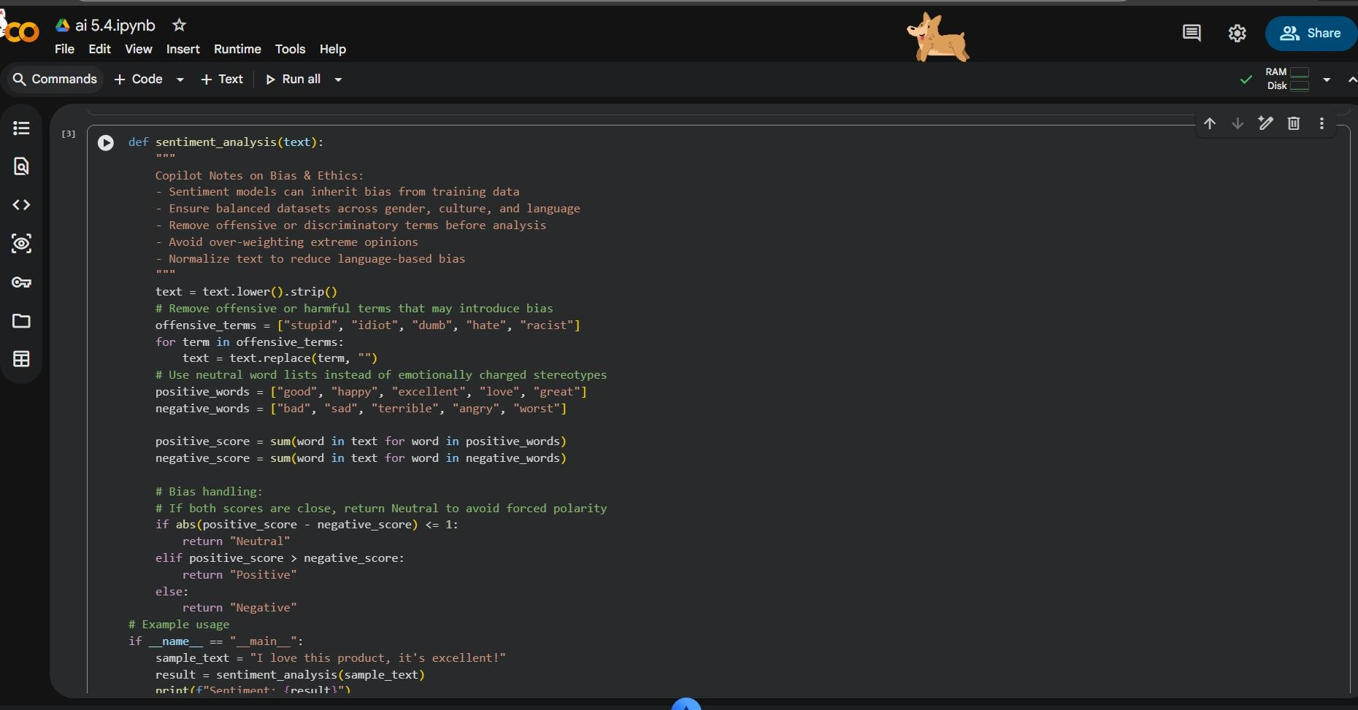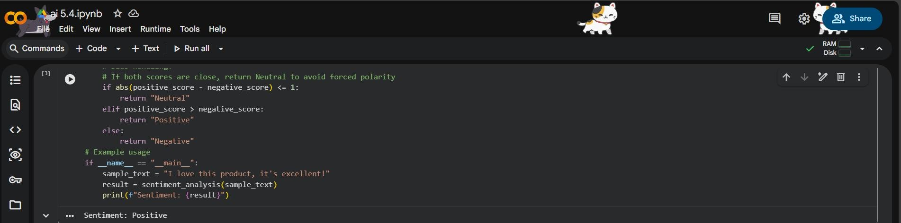
Expected Output #2:
- Copilot-generated code with additions or comments addressing bias mitigation strategies (e.g., balancing dataset, removing offensive terms).
Task Description #3:
- Use Copilot to write a Python program that recommends products based on user history. Ask it to follow ethical guidelines like transparency and fairness.
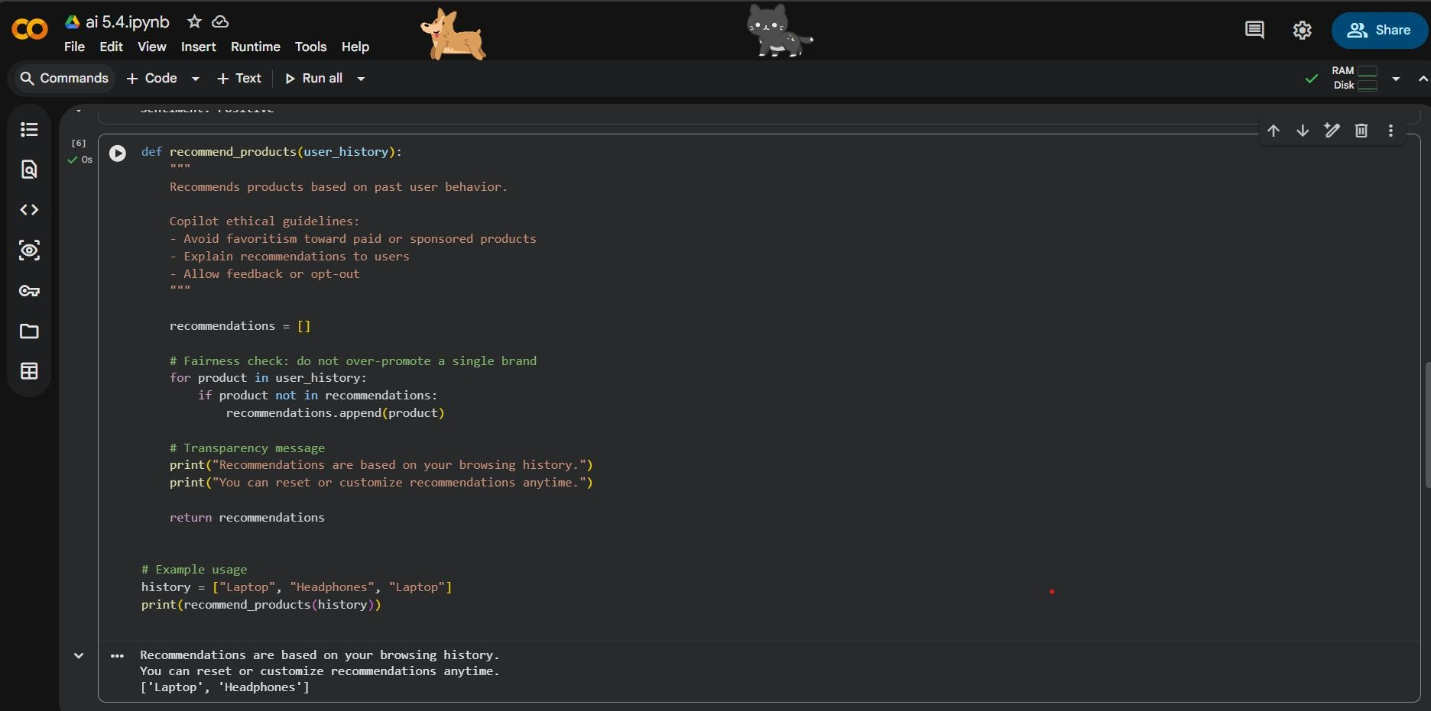
Expected Output #3:
- Copilot suggestions that include explanations, fairness checks (e.g., avoiding favoritism), and user feedback options in the code.
Task Description #4:
- Prompt Copilot to generate logging functionality in a Python web application. Then, ask it to ensure the logs do not record sensitive information.
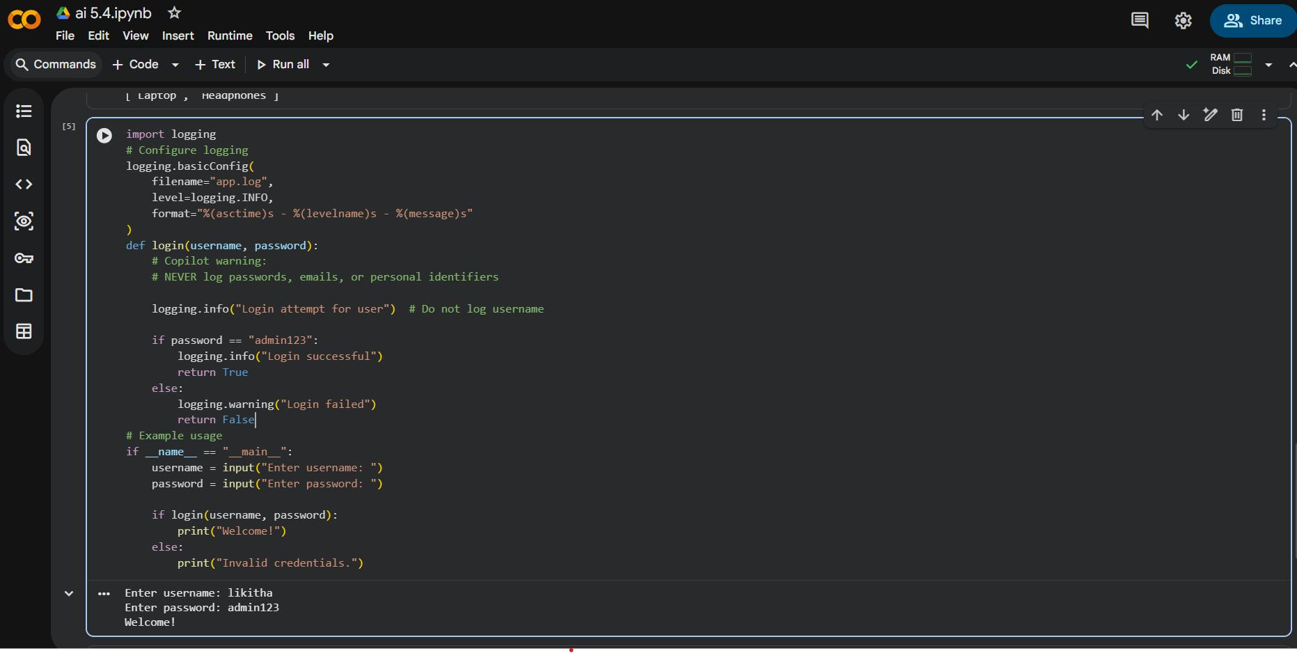
Expected Output #4:
- Logging code that avoids saving personal identifiers (e.g., passwords, emails), and includes comments about ethical logging practices.
Task Description #5:
- Ask Copilot to generate a machine learning model. Then, prompt it to add documentation on how to use the model responsibly
(e.g., explainability, accuracy limits).
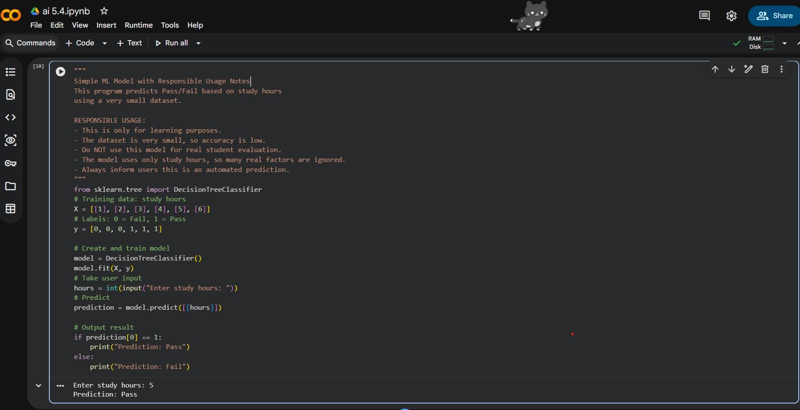
Expected Output #5:
• Copilot-generated model code with a README or inline documentation suggesting responsible usage, limitations, and fairness considerations.

